ATTENTION! READ BEFORE INSTALLING!
Engineered Rigid Plank Floating Floor and Glue Down Installation, Maintenance and Cleaning Instructions
INTRODUCTION:
Key Points In the Installation Process For Both Installation Methods

READ THESE INSTRUCTIONS THOROUGHLY BEFORE BEGINNING INSTALLATION. If
the following instructions leave any unanswered questions or if additional information is required, please call contact your sales representative.
SUBFLOOR PREPARATION
Subfloor must be level, dry and free of imperfections. An uneven subfloor will make the floor
feel unstable and cause premature damage. Remove all foreign substances such as wax, grease,
dirt and any substance or chemical that would interfere with a good bond. Test concrete subfloor for alkalinity (pH of floor should be between 5 and 9). Take corrective measures if concrete surface pH is outside these limits. Moisture tests should be performed using an anhydrous calcium chloride test according to ASTM F-1869 test method. Moisture emissions should not exceed 5.0 lbs. per 1000 square feet per 24 hours (2.27 kg/92.9m2/24 hours). Relative Humidity readings according to ASTM F-2170 should not exceed (RH) 85%. If both tests are performed the RH test is the qualifying standard. Fill all holes and cracks with a Portland cement based patching compound. Sand high spots, install underlayment grade plywood or particleboard underlayment over tongue and groove flooring to eliminate the possibility of telegraphing. For best results, the room, floor covering and adhesive should be between 65°F (18°C) and 95° F (35°C) and at a relative humidity between 30% and 60% for 24 hours before, during and after the installation.
FOR BEST VISUAL REPRESENTATION OF YOUR FLOOR
This flooring replicates the look of a natural product which has natural variations in color and
texture. For best visual effect, shuffle planks from several cartons and do not install similar
boards next to one another.
Responsibility for the suitability of FLOOR SOURCE flooring and accompanying products
for each individual installation cannot be assumed by FLOOR SOURCE, since FLOOR
SOURCE has no control over the installer's proper application. Should an individual plank
be doubtful as to appearance or dimension the installer should not use this piece.
NOTE: RIGID PLANKS may be installed with a direct glue-down method on approved wooden
(or) concrete substrates that are on, below or above grade. Use only a premium multipurpose
flooring adhesive.
- While the rigid planks waterproof, it’s not a moisture barrier. It’s still a good idea to
make sure concrete is cured and tested for moisture and that a moisture barrier is installed in the crawl space. Moisture won’t damage the rigid planks, but it can get in the walls and structure of the home. A couple of extra dollars and a few minutes is a small investment for the added protection and peace of mind. Use good common sense installation practices, and you’ll have a successful installation that results in a beautiful floor. Flooring should be one of the last items installed in any new construction or remodel project.
FLOORING MATERIAL SHOULD BE INSPECTED PRIOR TO INSTALLATION
PRE-INSTALLATION JOBSITE REQUIREMENTS AND INSPECTION
FLOOR SOURCE cannot be held responsible for site conditions.
Carefully examine the flooring prior to installation for color, finish and quality. Ensure adequate
lighting for proper inspection. If flooring is not acceptable, contact your supplier immediately and arrange for replacement. FLOOR SOURCE cannot accept responsibility for flooring installed with visible defects. Prior to installation of any flooring, the installer must ensure that the jobsite and subfloor meet the requirements of these instructions. FLOOR SOURCE is not responsible for flooring failure resulting from unsatisfactory jobsite and/or subfloor conditions.
Crawl spaces must be a minimum of 18′′ (46 cm) from the ground to the underside of the joists. A ground cover of 6–20 mil black polyethylene film is essential as a vapor barrier with joints lapped 6′′ (15 cm) and sealed with moisture resistant tape. The crawl space should have perimeter venting equal to a minimum of 1.5% of the crawl space square footage. These vents should be properly located to foster cross ventilation. Where necessary, local regulations prevail.
Room temperature and humidity of installation areas should be consistent with normal,
year-round living conditions before installing the floor. The floor should be stored in the
normal room temperature before installation.
STARTING YOUR INSTALLATION
- Before laying: Measure the room at right angle to the direction of the flooring. For the
best visual effect, planks or tiles in the final row should be at least 1/3 the width of the
plank or tile. For this purpose, planks or tiles in the first row can be cut to smaller size.
Shuffle boards in order to obtain a pleasant blend of shades. Lay boards, preferably
following the direction of the main source of light. We recommend laying on wooden
floors crossways to the existing floorboards
- Work from several open boxes of flooring and “dry lay” the floor before permanently
laying the floor. This will allow you to select varying textures, colors, and sheens, and to arrange them in a harmonious pattern. Remember, it is the installer’s responsibility to
determine the expectations of what the finished floor will look like with the end user first
and then to cull out pieces that do not meet those expectations.
- Begin installation next to an outside wall. This is usually the straightest and best reference for establishing a straight working line. Establish this line by measuring an equal distance from the wall at both ends and snapping a chalk line. The distance you measure from the wall should be the width of a plank or tile. You may need to scribe cut the first row of planks or tiles to match the wall in order to make a straight working line if the wall is out of straight.
- You may want to position a few rows before starting installation to confirm your layout
decision and working line. When laying flooring, stagger end joints from row to row by at
least 8" (20 cm) for planks, and equal to 12" (51 cm or a half piece) for tiles. For plank
installations, you can use the cut-off end to begin the next row when cutting the last plank in a row to fit. If cut-off end is less than 8”, discard it and instead cut a new plank at a random length (at least 8” in length) and use it to start the next row. For tile installations, always begin a row with either a full tile or a half tile so that the joints are consistently staggered in a “brick work” type pattern. Always begin each row from the same side of the room.
PRE-INSTALLATION SUBFLOOR REQUIREMENTS
All Subfloors must be
- Dry
- Structurally sound
- Clean: Thoroughly swept and free of all debris
- Level: Flat to 3/16” per 10-foot radius
- Wood subfloors must be dry and well secured. Nail or screw every 6” along joists to avoid
squeaking. If not level, sand down high spots and fill low spots with a Portland Based
leveling patch.
- Concrete subfloors must be fully cured, at least 60 days old, and should have minimum 6-mil polyfilm between concrete and ground.
- Subfloor should be flat and level within 3/16” per 10’ radius. If necessary grind high spots
down and level low spots with a Portland leveling compound.
- Ceramic Tile, resilient tile and sheet vinyl must be well-bonded to subfloor, in good
condition, clean and level. Do not sand existing vinyl floors, as they may contain asbestos.

FLOATING FLOOR INSTALLATION INSTRUCTIONS
INSTALLATION TOOLS
For all installation methods:
- Tape measure
- Tapping block (trimmed piece of flooring)
- Pencil
- Pry bar or pull bar
- Chalk line
- Crosscut power saw
- 3M Scotch-Blue™ 2080 Tape

Acceptable subfloor types:
- CDX Underlayment Grade Plywood (at least ½” thick)
- Underlayment grade particleboard
- OSB (at least ¾” thick)
- Concrete slab
- Existing wood floor
- Ceramic tile
- Resilient tile & sheet vinyl
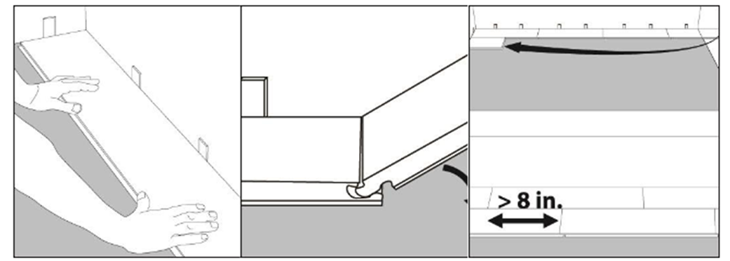
Step 1: Begin installation working from left to right. Insert spacers at ends and edges where planks meet wall.
Step 2: Lock short end of plank by inserting tongue into groove at an angle and drop in
place. Continue to end of first row.
Step 3: Use leftover plank at least 8” long to start next row. Tiles should by staggered 12” apart.
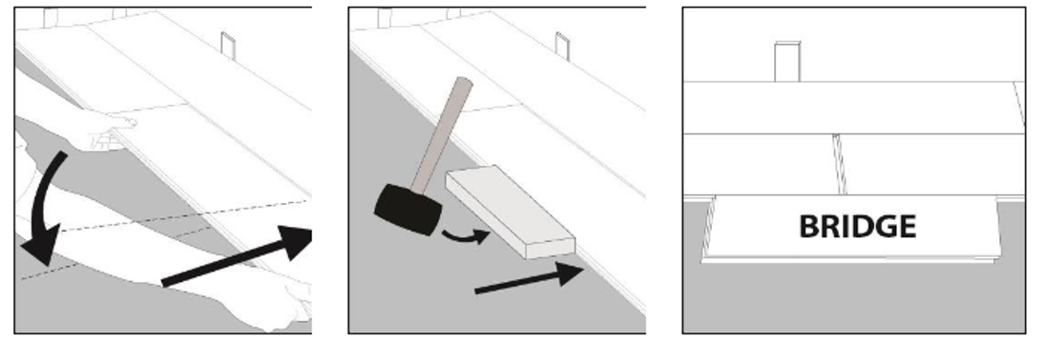
Step 4: Lock long edge of plank by inserting tongue into groove at an angle and drop in place. Slide plank toward end of previously installed plank until the tongue just touches the groove.
Step 5: IMPORTANT! Use hammer and tapping block to tap long edge of plank to ensure a tight fit. ANY GAPPING CAN COMPROMISE THE LOCKING SYSTEM!
Step 6: Attach a scrap piece of floor to bridge gap between boards.
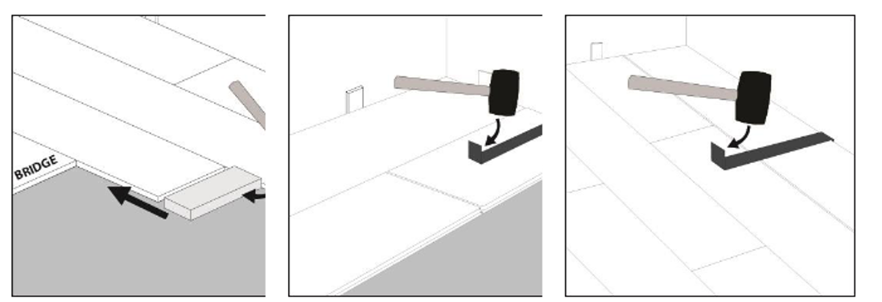
Step 7: Tap end of plank with hammer and tapping block to lock ends of planks together. Remove bridge and continue towards wall until installing the final plank in the row. BE SURE TO TAP ON EDGE OF RIGID SO AS NOT TO DAMAGE LOCKING PROFILE.
Step 8: Use hammer and pull bar to lock final piece in row. Insert spacer at end of row. Continue
installation to final row.
Step 9: Use hammer and pull bar to lock long edges of planks on final row.

INSTALLING UNDER DOOR JAMB
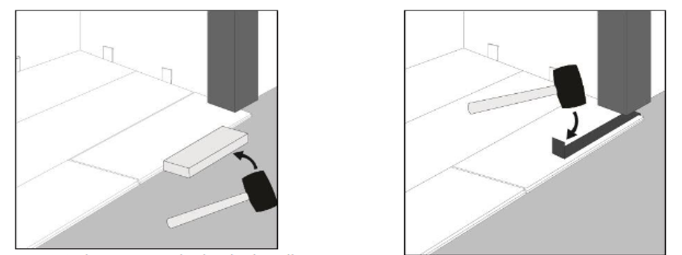
Step 1: Undercut space under door jamb to allow plank to slide freely. Tap long edge with hammer and tapping block to lock long edge.
Step 2: Use hammer and pull bar to lock short end of plank.
GLUE DOWN INSTALLATION INSTRUCTIONS
One of the key features of Rigid Planks is the ease and speed with which they install as a glueless floating floor. However, there are instances where the customer may wish to install these floors using the direct glue down method. In addition, there are two instances where FLOOR SOURCE requires that ENGINEERED RIGID PLANKS be installed using the direct glue down method:
- When installing engineered rigid planks in areas, such as sun rooms. Where the
floor is exposed to strong direct sunlight, where the temperature of the floor can
exceed 140° F. High heat exposure will result in dimensional stability changes
causing distortions.
- High traffic uses, especially in commercial applications
NOTE: Floor Source’s Hilltop Collection floors may be installed with a direct glue-
down method on approved wooden (or) concrete substrates that are on, above or
below grade only. The Hilltop Collection has an attached high-density EVA
underlayment pad. Please consult with adhesive manufacturer to determine if
suitable for use with this material.
When installing ENGINEERED RIGID PLANKS using the glue down method, adhesive should be used and applied to the subfloor using adhesive manufacturer’s recommended trowel. Surfaces must be clean, dry and smooth, free of voids, projections, loose materials, oil, grease, sealers, and all other surface contaminants. Maximum floor variation is 3/16” in 10’ radius for best installation results. Concrete slabs requiring patching or leveling should be repaired with Portland cement based material. Adhesive instructions should be followed completely.

When employing the direct glue down installation method, DO NOT include a 6-mil polyfilm vapor barrier in the assembly. Flooring material must be adhered directly to the subfloor.
INSTALLATION TOOLS
- Tape Measure
- Pencil
- Chalk Line
- Hammer
- Pull Bar
- 1/16” x 1/16” x 1/16” square-notch
- Adhesive
- Pencil
- Crosscut power saw
- Tapping block
ACCEPTABLE SUBFLOOR TYPES:
- Concrete: above, on and below grade
- APA registered plywood underlayment
- Hardboard
- Association grade particleboard
NOT RECOMMENDED for installation over existing vinyl flooring
When installing FLOOR SOURCE Hilltop Collection milled with the angle/tap profile
using the glue down method, adhesive should be used and applied to the subfloor using
adhesive manufacturer’s recommended trowel. Surfaces must be clean, dry and smooth,
free of voids, projections, loose materials, oil, grease, sealers, and all other surface
contaminants. Maximum floor variation is 1/8" in 10'. Concrete slabs requiring patching or leveling should be repaired with Portland cement based material. Adhesive manufacturer’s instructions should be followed completely.
TROWELS: Please follow adhesive recommendations.
Post Installation
• Remove adhesive residue using a clean cloth dampened with mineral spirits. Follow
label instructions
• Permit light foot traffic on the new floor after 3-4 hours giving the adhesive time to
set up.
• Keep furniture, fixtures and rolling traffic off the new floor for 48 hours.
• Wait 72 hours (3 days) before wet cleaning the new floor. This will allow the adhesive to fully cure.
IN-FLOOR RADIANT HEAT
Rigid Planks can be installed over in-floor or embedded radiant heat systems using the
floating or glue down method. When gluing floor, use a PREMIUM MULTI PURPOSE and
follow manufacturer’s recommended instructions.
- Turn the heat off for 24 hours before, during and 24 hours after installation when
installing over radiant heated subfloors.
- Failure to turn the heat off may result in significantly shortened working time of the
adhesive
- Floor temperature must not exceed 85°F (30°C).
- Once the installation has been completed, the heating system should be turned on and
increased gradually (in increments of 5° F) until returning to normal operating conditions.
- Failure to strictly follow adhesive manufacturer’s guidelines may result in failure and
void the warranty.
Warning: Electric heating mats that are not embedded into the subfloor are not
recommended for use underneath Rigid Planks. Using electric heating mats that are not
embedded and applied directly underneath Rigid Planks could void the warranty for your
floor in case of failure. It is best to install Rigid Planks over embedded radiant floor
heating systems and adhere to the guidelines listed above.
AFTER INSTALLATION
- In order to protect the floors while other trades are finishing their work prior to final
cleanup and turnover to the owner, use rosin paper and only use 3M Scotch-Blue™ 2080 Tape to hold the rosin paper to the floor (other blue tapes may damage the finish). Clean the floor thoroughly before laying the rosin paper to ensure that no debris is trapped underneath. DO NOT USE plastic film or other non-breathing coverings as this can cause the floor to become damaged from humidity buildups.
- Dust mop or vacuum your floor to remove any dirt or debris.
- It is suggested that you buff the floor with lamb’s wool pads in order to remove any loose
splinters, residues, foot prints, etc.
PROTECTION AND MAINTENANCE OF YOUR FLOOR
Safety Precautions
- When performing any wet maintenance, always put out wet floor signs and caution tape.
- When wet maintenance is finished and the floor is dry, remove all caution signs & tape.
Carefully read and follow each product’s label instructions for proper use.
- Refer to each product’s MSDS for use of personal protective equipment.
Lasting beauty can be achieved through purchasing a quality floor covering and providing proper on-going maintenance.
- Furniture should be moved onto the newly installed floor using an appliance hand truck
over hardboard runways. NEVER drag any furniture across the floor.
- Avoid exposure to long periods of direct sunlight. Close blinds or drapes during peak
sunlight hours. Floor covering subjected to excessive heat and light is subject to thermal degradation and, in the case of engineered rigid planks, to changes in dimensional
stability. Use appropriate precautions to minimize potential effects on the floor covering.
- Oil or petroleum-based products can result in surface staining. Do not track asphalt-
driveway sealer or automobile-oil drips onto the rigid floor covering.
- Use non-staining mats. Rubber may discolor the floor.
- All furniture should be equipped with felt pads to avoid scratching the floor. Heavy
furniture and appliances should be equipped with non-staining large surface floor
protectors. Furniture with castors or wheels must be easy swiveling, large surface non-
staining and suitable for resilient floors. Do NOT use ball type castors as they can
damage the floor. Chair mats must be used to protect floors from rolling chairs.
- Use walk off mats at entrances to prevent dirt and grit from being tracked on to the floor.
- Sweep or vacuum the floor regularly to remove loose dirt. Do NOT use vacuums that use a beater bar or turn beater bar off.
- Do NOT use electric brooms with hard plastic bottoms with no padding.
- Clean up spills immediately.
- Damp mop as needed using clean water and a diluted floor cleaner. Do NOT use harsh
cleaners or chemicals on the floor. Do NOT use abrasive scrubbing tools. Do NOT use
detergents, abrasive cleaners or “mop and shine” products.
- Rigid Flooring, like other types of smooth floors, may become slippery when wet. Allow
time for floor to dry after washing. Immediately wipe up wet areas from spills, foreign
substances or wet feet.
- If the flooring is scratched, the factory recommends using the following scratch fix:
o http://www.1877floorguy.com/scratchfix.html
Initial & Routine Maintenance (Daily or as needed)
- Sweep, dust mop or vacuum the floor to remove all loose dirt and grit. Do not use treated dust mops.
- Clean the floor using a properly diluted Neutral pH cleaner in cool water. Follow label
instructions.
- Mop or machine clean using 175-rpm “Swing-arm” machine or auto scrubber with a 3M
5100 Red pad (or equal).
- Rinse the floor thoroughly with clean water and allow it to dry. Fans or air movers can
speed up the drying time.
Daily Cleaning Directions
- Sweep floor to remove loose dirt & soil.
- Using Mop & Bucket (2-bucket system) or mop floor with the cleaning solution.
- Trail mop excess soil and wet areas with a clean, tightly wrung out mop.
- No rinsing required.
- Allow floor to air dry completely.
Prevention
- The single greatest cause of damage to any flooring or floor finish is abrasion from
dirt and grit. Wherever possible, use walk off mats at entrances and doorways.
Use non-staining floor protectors under heavy furniture, chairs, and tables.

